**FIBC Bulk bags Parameter Selection Manual**

1, Product name will loaded with this bag:

2, Length, width and height for this bag

3, Required load-bearing capacity

4, Top type (Duffle Top, Full Open Top, Spout Top)

5, Bottom type (Spout Bottom, Plain Bottom)

6, Other special requirements

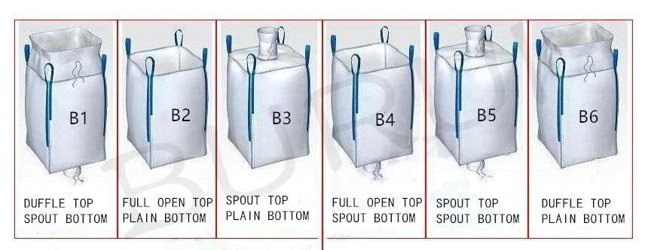

If you have any questions, please feel free to contact me

Email: [danielliu993@126.com](mailto:danielliu993@126.com)

Tel: +86 18562033660